**Memo**

To: Professor Pisano

From: Nick Gutierrez, Seok Young Choi, Yumin Lisa Wei, Eunhye Kwon

Team: 24

Date: 11/15/22

Subject: Prototype Demo Testing Plan

1. **Required Materials**

Hardware:

* Arduino Micro
* 1 Micro USB to USB A cord
* 8 push buttons
* 8 LEDs of varying colors
* 16 10K Ohm Resistors
* Adafruit MPR121 12-Key Capacitive Touch Sensor Breakout

Software:

* Arduino code
  + Reads inputs from push buttons and maps them to controller inputs which are then sent over USB to the computer
  + Reads push button inputs and lights/unlights corresponding LED
* Gamepad HTML tester website
  + <https://gamepad-tester.com/>
* 1 copy of Portal Reloaded to demo in game functionality

**2.0 Setup**

1. Plug in the arduino by connecting the Micro USB to the USB A port on the demo computer
2. If the Gamepad code is not pushed, set the Arduino IDE board to Arduino Micro w/ XInput and push the code
3. Press a couple of buttons to verify inputs are being registered
4. Open the Gamepad Tester site and verify the controller is being picked up

**3.0 Testing Procedure**

1. Press every button on the device and show every corresponding LED lighting when pressed and unlighting when unpressed
2. Open Gamepad testing site and demo each button/joystick corresponding to the correct gamepad output
3. Open Portal Reloaded and show the controller inputs begin the corresponding action in the game
   1. Joystick Left/Right push will act as Left/Right Trigger so full game actions can be shown
4. Complete the chosen level of Portal Reloaded

**4.0 Measurable Criteria**

* LEDs light when their corresponding buttons are pressed
* Gamepad testing site shows correct output for controller inputs
  + Both buttons and joysticks
* Level of Portal Reloaded is demonstrated and completed

**5.0 Arduino Pinout**

| **Arduino Pin** | **Output** |
| --- | --- |
| D9 | LED 1 ON/OFF |
| D10 | LED 2 ON/OFF |
| D11 | LED 3 ON/OFF |
| D12 | LED 4 ON/OFF |
| D13 | LED 5 ON/OFF |
| D1 | LED 6 ON/OFF |
| D17 | LED 7 ON/OFF |
| D16 | LED 8 ON/OFF |

**6.0 Arduino Input to Controller Button Mapping**

| **Arduino Button** | **Controller Button** |
| --- | --- |
| 1 | Start |
| 2 | Select |
| 3 | A |
| 4 | X |
| 5 | Y |
| 6 | B |
| 7 | RB |
| 8 | LB |
| Joystick Left Push | LT |
| Joystick Right Push | RT |

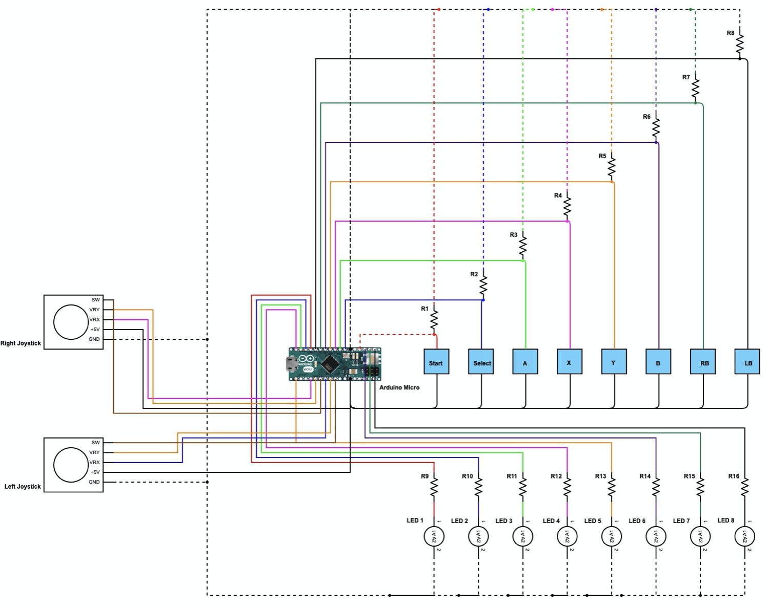

**Figure 1**: Schematic of controller. This controller has an Arduino Micro, 8 push buttons, 16 10K ohm resistors, two joysticks, and 8 LED lights.

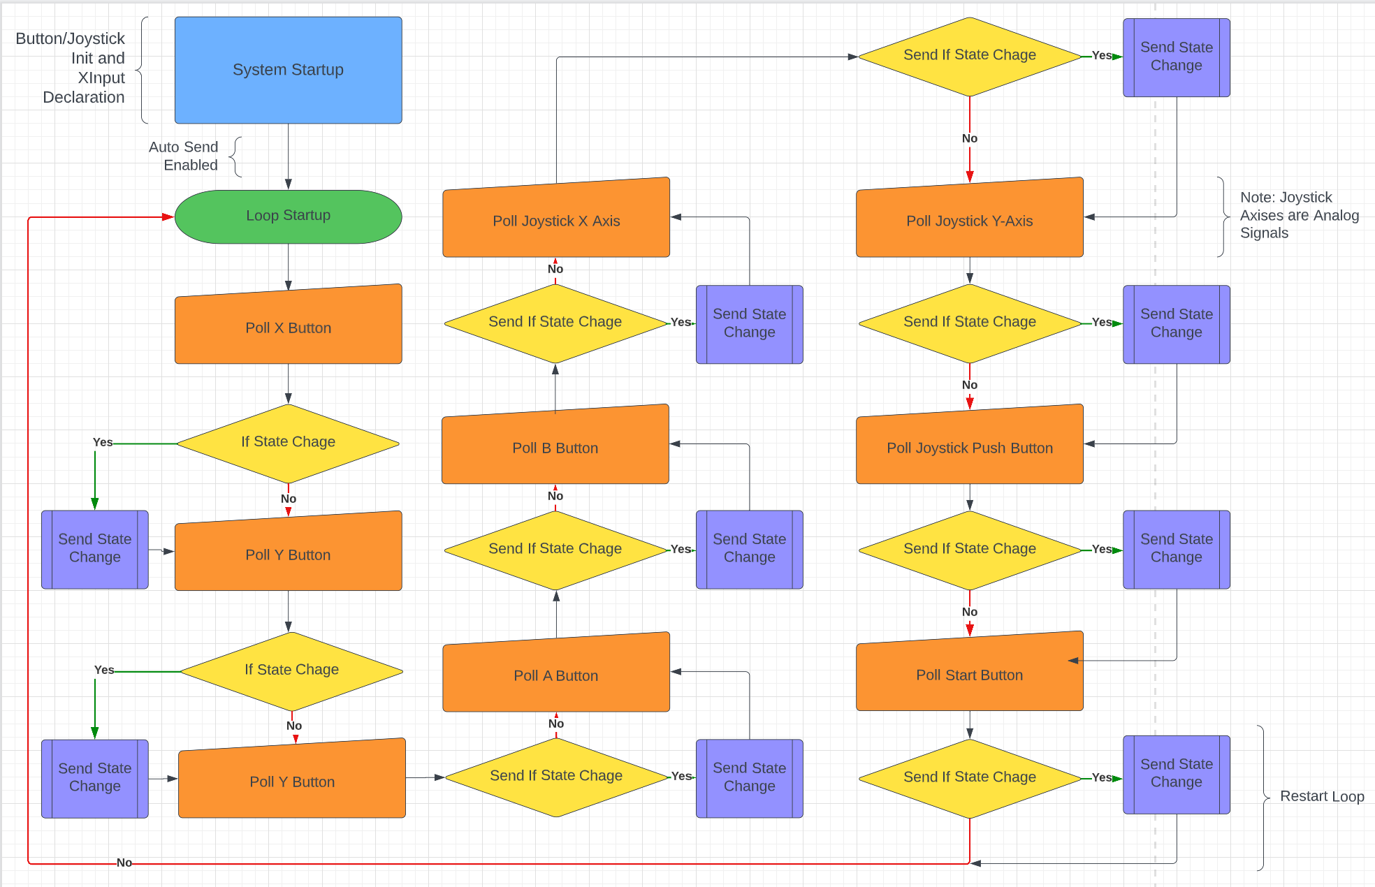

**Figure 2:** Software Flow Diagram of Controller

**7.0 Score Sheet**

**7.1 Controller Hardware/Software Testing**

**Table 1**: Controller buttons and joysticks testing results. The functionality of buttons and joysticks will be tested through LED outputs, gaming controller outputs, and game action performances.

| Button | Led Lit? | Correct Controller Output? | Game Action Performed? | Total Score |
| --- | --- | --- | --- | --- |
| 1 | Yes | Yes | Yes | 100 |
| 2 | Yes | Yes | Yes | 100 |
| 3 | Yes | Yes | Yes | 100 |
| 4 | Yes | Yes | Yes | 100 |
| 5 | Yes | Yes | Yes | 100 |
| 6 | Yes | Yes | Yes | 100 |
| 7 | Yes | Yes | Yes | 100 |
| 8 | Yes | Yes | Yes | 100 |
| Left Joystick Push | N/A | Yes | Yes | 100 |
| Right Joystick Push | N/A | Yes | Yes | 100 |

**7.2 Capacitive Touch Sensor Testing**

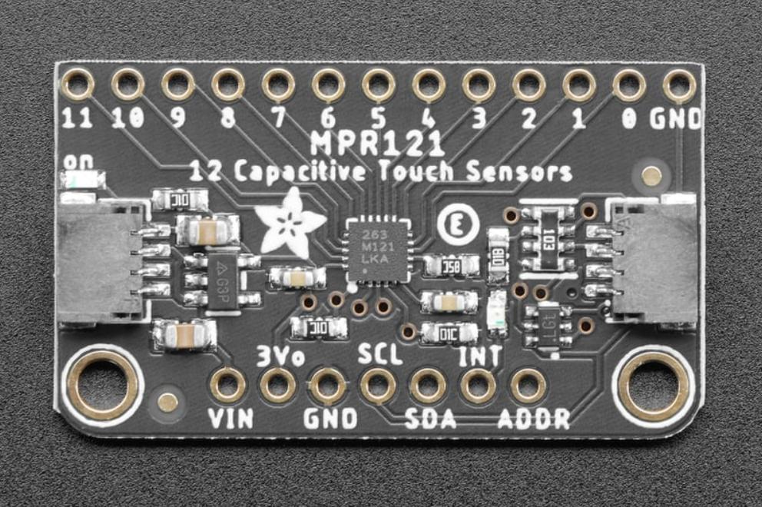

**Figure 1:** Adafruit MPR121 12-Key Capacitive Touch Sensor Breakout is used in E-Remote. The MPR121 has 12 sensor pins that will replace push buttons in the initial hardware.

**Table 2:** Results of Adafruit MPR121 Sensor Material Conductivity Testing. The purpose of this test was to determine the material(s) that could be used as touch sensor pads of E-Remote.

| **Material** | **Conductive? Y/N** |
| --- | --- |
| Plastic bag | N |
| Surgical Glove | Y |
| Cloth | N |
| Aluminum Metal | Y |
| 3D printer plastic filament | N |
| Paper | N |
| Plastic | N |
| Metal clip | Y |

It is concluded that we need a conductive material for the touch sensor pads. Aluminum or steel metal sheets would work best for our design. The metal sheet would have laser cut holes so that LED light can shine through. The metal sensor would be protected with a conductive plastic film.